Comparación curva teórica vs práctica.
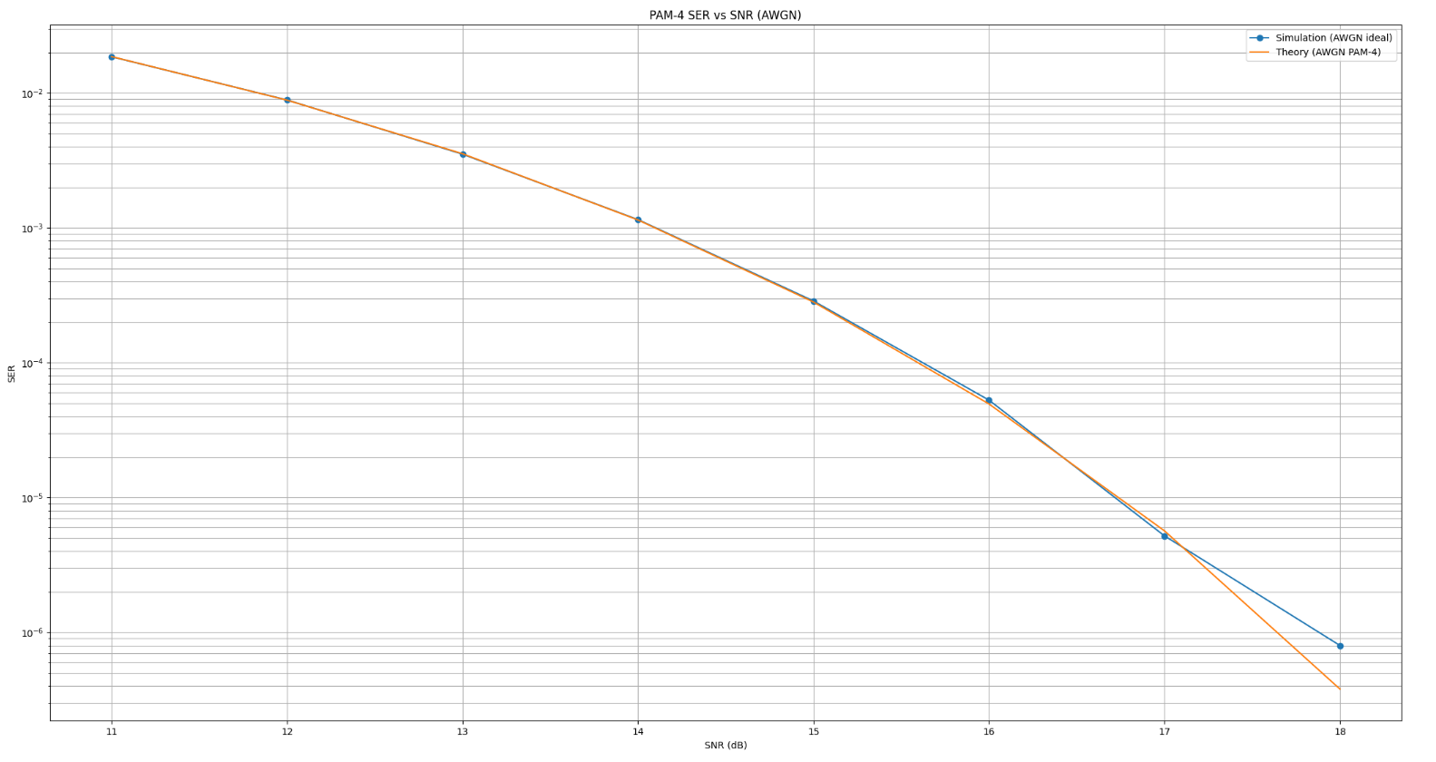
Comparaciones curvas con distintos pasos.
- - - - - - - - - - - - - - - - - - - - -
STARTING SIMULATION: PAM 4 EQUALIZER
Bit Rate: 8.00Gbps
Symbol Rate: 4.00GBd
Band Width: 2.00GHz

=== mu = 1.0e-06 ===
CASE 0: SNR DB = 11
SER: 2.005155e-02 (196505/9799990)
CASE 1: SNR DB = 12
SER: 9.670622e-03 (94772/9799990)
CASE 2: SNR DB = 13
SER: 3.997351e-03 (39174/9799990)
CASE 3: SNR DB = 14
SER: 1.378063e-03 (13505/9799990)
CASE 4: SNR DB = 15
SER: 3.630616e-04 (3558/9799990)
CASE 5: SNR DB = 16
SER: 7.663273e-05 (751/9799990)
CASE 6: SNR DB = 17
SER: 1.551022e-05 (152/9799990)
CASE 7: SNR DB = 18
SER: 1.734696e-06 (17/9799990)

=== mu = 5.0e-06 ===
CASE 0: SNR DB = 11
SER: 2.028716e-02 (198814/9799990)
CASE 1: SNR DB = 12
SER: 9.663785e-03 (94705/9799990)
CASE 2: SNR DB = 13
SER: 3.928677e-03 (38501/9799990)
CASE 3: SNR DB = 14
SER: 1.315205e-03 (12889/9799990)
CASE 4: SNR DB = 15
SER: 3.635718e-04 (3563/9799990)
CASE 5: SNR DB = 16
SER: 8.744907e-05 (857/9799990)
CASE 6: SNR DB = 17
SER: 1.755104e-05 (172/9799990)
CASE 7: SNR DB = 18
SER: 5.204087e-06 (51/9799990)

=== mu = 1.0e-05 ===
CASE 0: SNR DB = 11
SER: 2.003237e-02 (196317/9799990)
CASE 1: SNR DB = 12
SER: 9.524806e-03 (93343/9799990)
CASE 2: SNR DB = 13
SER: 3.770718e-03 (36953/9799990)
CASE 3: SNR DB = 14
SER: 1.235511e-03 (12108/9799990)
CASE 4: SNR DB = 15
SER: 2.994901e-04 (2935/9799990)
CASE 5: SNR DB = 16
SER: 5.897965e-05 (578/9799990)
CASE 6: SNR DB = 17
SER: 7.040824e-06 (69/9799990)
CASE 3: SNR DB = 14
SER: 1.235614e-03 (12109/9799990)
CASE 4: SNR DB = 15
SER: 3.058166e-04 (2997/9799990)
CASE 3: SNR DB = 14
SER: 1.235614e-03 (12109/9799990)
CASE 4: SNR DB = 15
SER: 3.058166e-04 (2997/9799990)
CASE 5: SNR DB = 16
SER: 5.408169e-05 (530/9799990)
CASE 6: SNR DB = 17
SER: 5.102046e-06 (50/9799990)
CASE 7: SNR DB = 18
SER: 4.081637e-07 (4/9799990)
PS C:\Maestria\Maestria_ignacio_balbo\Work>

CASE 3: SNR DB = 14
SER: 1.235614e-03 (12109/9799990)
CASE 4: SNR DB = 15
SER: 3.058166e-04 (2997/9799990)
CASE 5: SNR DB = 16
SER: 3.058166e-04 (2997/9799990)
CASE 5: SNR DB = 16
SER: 5.408169e-05 (530/9799990)
CASE 6: SNR DB = 17
SER: 5.102046e-06 (50/9799990)
CASE 7: SNR DB = 18
SER: 4.081637e-07 (4/9799990)
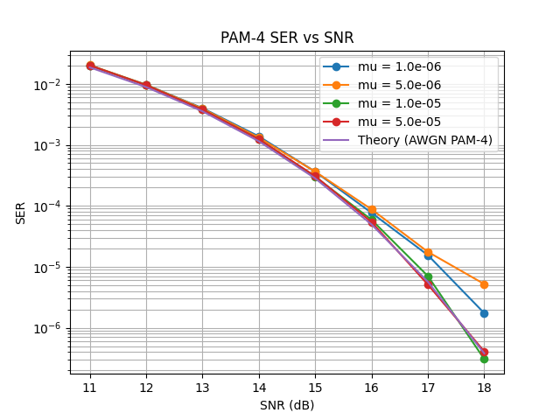
Isi noise ffe
- - - - - - - - - - - - - - - - - - - - -
STARTING SIMULATION: PAM 4 EQUALIZER
Bit Rate: 8.00Gbps
Symbol Rate: 4.00GBd
Band Width: 2.00GHz

CHANNEL DESIGN: FIR
Attenuation at 2.00 GHz: -12.52 dB

SNR values: [11 12 13 14 15 16 17 18]

CASE 0: SNR DB = 11
# NOISE DB = -14.010299956639813
SER: 4.852780e-02 (475572/9799990)
CASE 1: SNR DB = 12
# NOISE DB = -15.010299956639813
SER: 2.948064e-02 (288910/9799990)
CASE 2: SNR DB = 13
# NOISE DB = -16.010299956639813
CHANNEL DESIGN: FIR
Attenuation at 2.00 GHz: -12.52 dB

SNR values: [11 12 13 14 15 16 17 18]

CASE 0: SNR DB = 11
# NOISE DB = -14.010299956639813
SER: 4.852780e-02 (475572/9799990)
CASE 1: SNR DB = 12
# NOISE DB = -15.010299956639813
SER: 2.948064e-02 (288910/9799990)
CASE 2: SNR DB = 13
# NOISE DB = -16.010299956639813
CASE 1: SNR DB = 12
# NOISE DB = -15.010299956639813
SER: 2.948064e-02 (288910/9799990)
CASE 2: SNR DB = 13
# NOISE DB = -16.010299956639813
# NOISE DB = -16.010299956639813
SER: 1.650328e-02 (161732/9799990)
CASE 3: SNR DB = 14
# NOISE DB = -17.010299956639813
SER: 8.267049e-03 (81017/9799990)
CASE 4: SNR DB = 15
# NOISE DB = -18.010299956639813
SER: 3.796534e-03 (37206/9799990)
CASE 5: SNR DB = 16
# NOISE DB = -19.010299956639813
SER: 1.535818e-03 (15051/9799990)
CASE 6: SNR DB = 17
# NOISE DB = -20.01029995663981
SER: 5.439801e-04 (5331/9799990)
CASE 7: SNR DB = 18
# NOISE DB = -21.010299956639813
SER: 1.618369e-04 (1586/9799990)
SNR SER
11 4.85e-02
12 2.95e-02
13 1.65e-02
14 8.27e-03
15 3.80e-03
16 1.54e-03
17 5.44e-04
18 1.62e-04
